Data Visualization & Communication
A Visual Analytics Report on the Hotel Bookings Dataset
________________________________________
Prepared by: Abhiram Chander Sai Jandhyala
B.Tech Information Technology, JBIET, Hyderabad
Notebook: Data-Visualization-Communication.ipynb | Dataset: hotel_bookings_cleaned.csv
87,203 bookings analyzed • 15 visualizations • 1 predictive model

Table of Contents

1. Introduction
Hotels increasingly rely on data to understand who books, why they cancel, and what drives revenue. This report presents a structured visual analysis of a cleaned hotel bookings dataset containing 87,203 reservations across two property types — City Hotel and Resort Hotel — spanning booking channels, guest profiles, pricing, and stay patterns.
The goal is not just to display charts, but to communicate insight: each visualization below was chosen deliberately for the shape of the question it answers — composition, distribution, comparison, relationship, or correlation — and is interpreted in the context of what it means for hotel operations, pricing, and cancellation risk.
The analysis closes with a predictive modeling exercise: a Random Forest classifier trained to flag bookings likely to be cancelled, evaluated through a feature-importance chart and an ROC curve, turning the descriptive visuals into an operationally actionable tool.

1.1 Dataset & Tools
- Records: 87,203 hotel bookings, 36 columns (booking, guest, pricing, and stay attributes).
- Hotel types: City Hotel and Resort Hotel.
- Target-relevant field: booking_status (Cancelled / Not Cancelled), derived from is_canceled.
- Tools: Python — pandas and numpy for data handling, matplotlib and seaborn for visualization, scikit-learn (RandomForestClassifier) for predictive modeling.
- Styling: ggplot matplotlib theme with seaborn's whitegrid style, chosen for clean gridlines that aid quantitative reading without cluttering the plot.

1.2 How to Read This Report
Each visualization is presented with three consistent lenses: (1) what technique was chosen and why it fits the data type; (2) what the chart actually shows in this dataset; and (3) why that finding matters for the broader business context of hotel revenue management and cancellation control.

2. Booking Composition & Guest Profile
This first group of charts establishes who is booking, through which channel, and under what conditions — the categorical backbone of the dataset.

2.1 Hotel Type Distribution
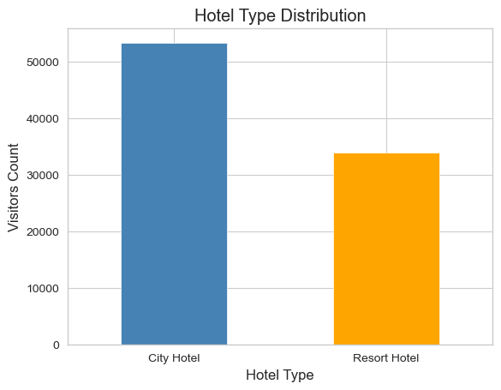
Figure 1. Bar chart of bookings by hotel type.
Technique: A vertical bar chart, the standard choice for comparing counts across a small number of discrete categories, since bar length maps directly and unambiguously to magnitude.
Insight: City Hotel accounts for 53,272 bookings (61.1%) versus 33,931 (38.9%) for Resort Hotel — City Hotel draws roughly 1.6x the reservation volume.
Relevance: Volume is not split evenly, so downstream KPIs (cancellation rate, ADR, occupancy planning) should be read separately per hotel type rather than pooled, since City Hotel's behaviour will dominate any blended average.

2.2 Share of Total Bookings by Hotel Type
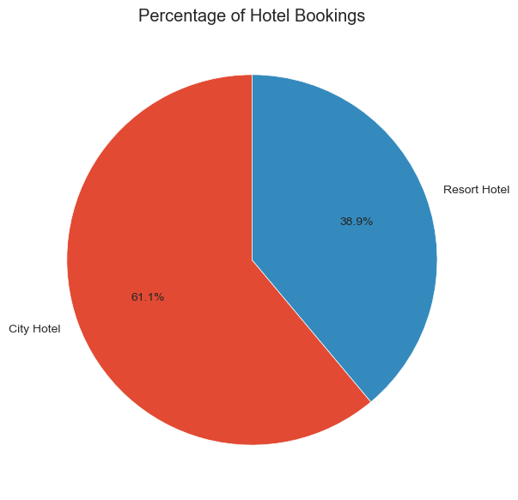
Figure 2. Pie chart of the same hotel-type split, shown as a proportion.
Technique: A pie chart, used deliberately here — with only two categories that sum to a meaningful whole (100% of bookings) — to foreground the part-to-whole relationship that a bar chart states as raw counts but a pie chart states as immediate proportion.
Insight: The pie reinforces the 61%/39% split visually as roughly a 3:2 ratio, making the relative dominance of City Hotel easier to grasp at a glance than the equivalent bar heights.
Relevance: For stakeholders who think in market share rather than raw counts (e.g., portfolio or investment reviews), the proportional framing communicates the same fact more intuitively — pairing Figures 1 and 2 satisfies both audiences.

2.3 Booking Cancellation Status
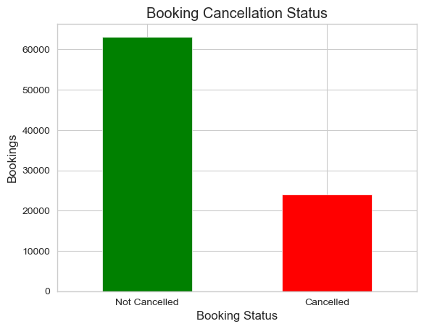
Figure 3. Bar chart of confirmed vs. cancelled bookings.
Technique: A two-category bar chart with a green/red color contrast, deliberately mapping color to outcome polarity (kept vs. lost) so the business meaning is legible even before reading the axis labels.
Insight: 63,195 bookings (72.5%) were not cancelled, while 24,008 (27.5%) were — meaning more than one in four reservations never materializes into a stay.
Relevance: A 27.5% cancellation rate is the central business problem this report builds toward: it directly motivates the predictive model in Section 4, which tries to flag high-risk bookings before they cancel.

2.4 Customer Type Distribution
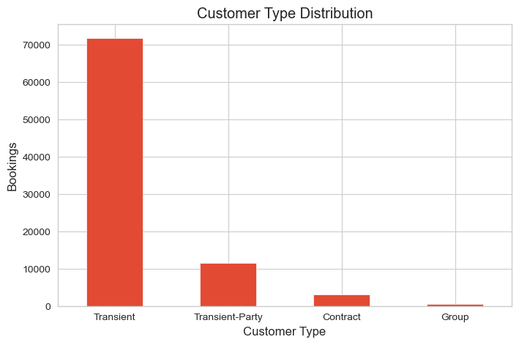
Figure 4. Bar chart of bookings by customer type.
Technique: A bar chart with four categories, appropriate once category count grows beyond two — bars stay easy to compare side by side, where a pie chart would become cluttered.
Insight: Transient guests dominate with 71,844 bookings, followed by Transient-Party at 11,683, Contract at 3,135, and Group at just 541 — individual, non-grouped travel is overwhelmingly the norm.
Relevance: Because Transient guests make up the vast majority, marketing and cancellation-mitigation strategies aimed at this single segment will have outsized impact compared to efforts spread evenly across all four types.

2.5 Market Segment Distribution
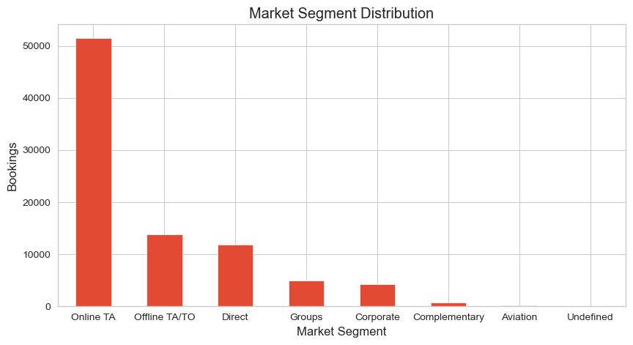
Figure 5. Bar chart of bookings by market segment (widened to fit 8 category labels).
Technique: A wider bar chart to accommodate more categories and longer labels without overlap — figure width was deliberately increased for this variable versus Figures 1–4.
Insight: Online Travel Agents (Online TA) lead by a wide margin at 51,548 bookings, followed by Offline TA/TO (13,852) and Direct (11,774); Complementary and Aviation segments are negligible.
Relevance: The heavy reliance on Online TA channels signals both an acquisition-cost dependency (commission fees) and a cancellation-risk factor, since OTA bookings are typically easier for guests to cancel or rebook than direct reservations.

2.6 Meal Preference Distribution
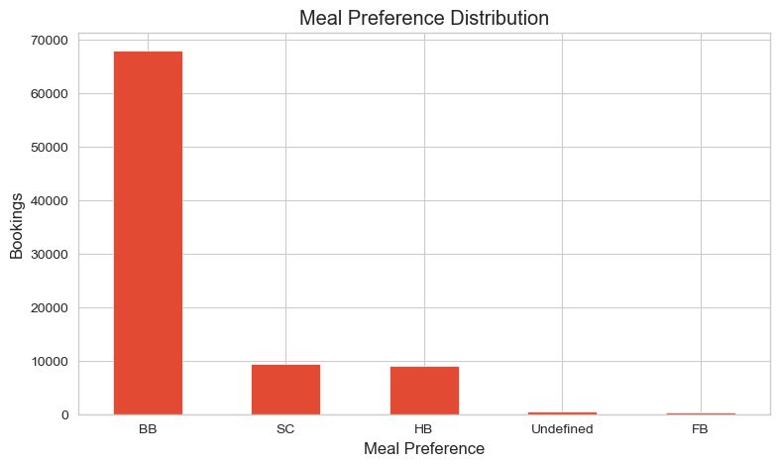
Figure 6. Bar chart of bookings by meal plan.
Technique: A standard categorical bar chart, kept consistent with the earlier charts in this section for visual continuity across the guest-profile group.
Insight: Bed & Breakfast (BB) is overwhelmingly the most selected plan at 67,883 bookings, dwarfing Self Catering (9,391), Half Board (9,079), and Full Board (360).
Relevance: BB's dominance suggests it should be the default/bundled offering in pricing packages, while the small Full Board segment may warrant investigation as a premium, low-volume niche rather than a mainstream option.

2.7 Top 10 Countries by Bookings
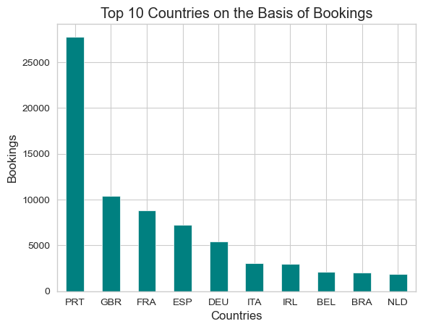
Figure 7. Bar chart of the ten countries generating the most bookings.
Technique: A ranked bar chart limited to the top 10 (via .head(10)) rather than plotting all countries — a deliberate filtering choice, since a full country list would be unreadable and the long tail carries little individual weight.
Insight: Portugal (PRT) is the dominant source market with 27,779 bookings — over 2.5x the next-highest country, the United Kingdom (10,422) — followed by France (8,823), Spain (7,244), and Germany (5,385).
Relevance: The Portugal concentration likely reflects the hotels' domestic market and should be treated as the baseline guest base; the UK, France, Spain, and Germany represent the core international feeder markets worth targeted marketing investment.

3. Pricing, Duration & Relationships
This section shifts from categorical composition to numerical distributions and relationships — how prices, lead times, and stay lengths behave, and how they relate to each other.

3.1 Average Daily Rate (ADR) Distribution
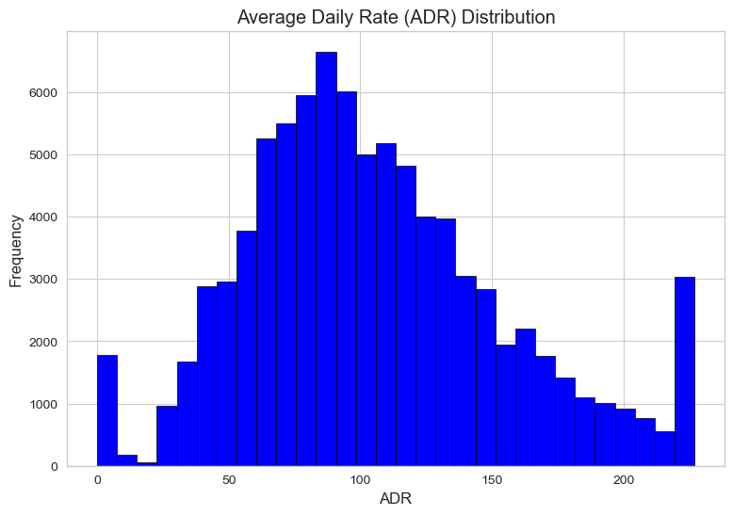
Figure 8. Histogram of Average Daily Rate across all bookings.
Technique: A histogram with 30 bins, the right tool for visualizing the shape of a single continuous variable's distribution — where a bar chart would need pre-aggregated categories, a histogram reveals skew, spread, and modality directly from raw values.
Insight: ADR is right-skewed with a mean of $105.53 and median of $98.25 (min $0, max $226.88); the bulk of bookings cluster between roughly $72 and $134 (the interquartile range), with a long tail of higher-priced stays.
Relevance: Because mean exceeds median, a handful of high-ADR bookings pull the average upward — pricing strategy and revenue forecasts should reference the median or IQR rather than the mean alone to avoid overstating typical guest spend.

3.2 Lead Time Distribution
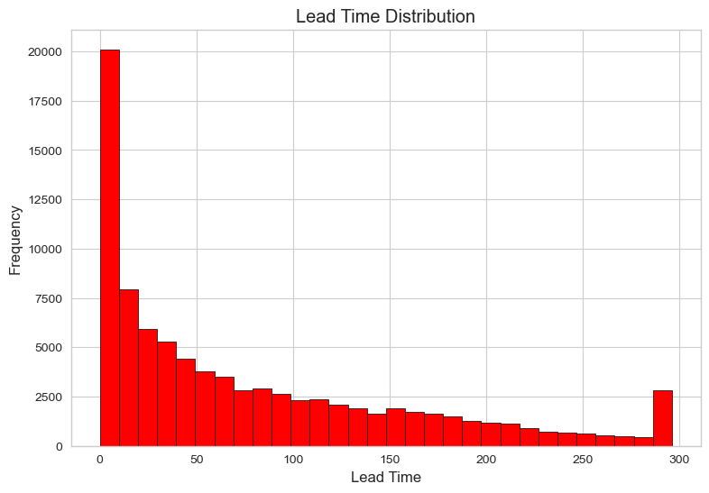
Figure 9. Histogram of booking lead time (days between booking and arrival).
Technique: A second histogram, using a contrasting color (red vs. blue in Figure 8) to visually distinguish it while keeping the same 30-bin, distribution-shape approach for a fair comparison of variable behaviour.
Insight: Lead time is heavily right-skewed: the median is 49 days but the mean is 78.5, with a long tail stretching out to 296 days; 25% of bookings are made just 11 days or fewer before arrival.
Relevance: Lead time later proves to be the single strongest predictor of cancellation (Section 4) — this histogram's long tail is the raw signal behind that finding: bookings made far in advance have much more time and opportunity to be cancelled or changed.

3.3 ADR by Hotel Type
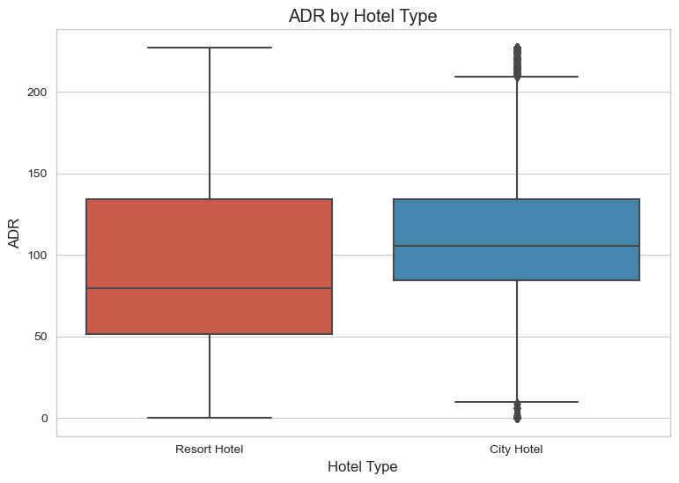
Figure 10. Box plot of ADR, split by hotel type.
Technique: A box plot, chosen specifically because it compares the full distribution (median, quartiles, spread, outliers) of a continuous variable across two groups — richer than comparing two single averages, and better suited than overlapping histograms for a clean side-by-side comparison.
Insight: City Hotel has a noticeably higher median ADR ($105.30) than Resort Hotel ($79.66), with City Hotel's box also showing a wider spread of pricing.
Relevance: Combined with Figure 1's volume split, City Hotel is both the higher-volume and higher-priced property type, making it the primary revenue driver in this portfolio and the natural focus for yield-management efforts.

3.4 Total Guests vs. Average Daily Rate
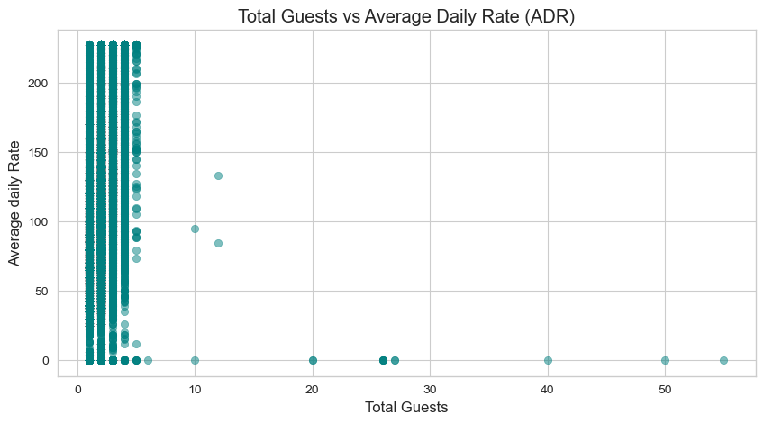
Figure 11. Scatter plot of total guests against ADR.
Technique: A scatter plot with partial transparency (alpha=0.5), the appropriate technique for visualizing the relationship between two continuous variables at the individual-record level — transparency was added specifically to reveal density in overplotted regions rather than a single solid blob.
Insight: There is a moderate positive relationship between party size and price (correlation ≈ 0.40): larger guest counts tend to associate with higher ADR, consistent with per-person or per-bed pricing, but the relationship is loose rather than tight — many small parties also pay high rates.
Relevance: Because the correlation is moderate rather than strong, ADR is not simply a function of party size — room type, season, and channel likely contribute meaningfully too, which the correlation heatmap in Figure 13 helps contextualize further.

3.5 Distribution of Total Nights Stayed
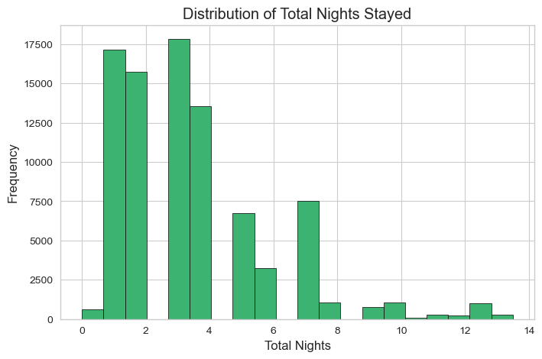
Figure 12. Histogram of total nights per booking.
Technique: A histogram with 20 bins and a distinct green fill, keeping the distribution-shape approach consistent with Figures 8 and 9 while visually separating it as a different subject (duration rather than price/time).
Insight: Stay length is right-skewed and concentrated at short durations: the median stay is 3 nights (mean 3.58), with 75% of bookings at 5 nights or fewer, and a thinning tail out to 13.5 nights.
Relevance: Short-stay dominance (2–5 nights) suggests a leisure/short-break-oriented guest base rather than long-stay or extended-business travel, which has implications for housekeeping turnover planning and minimum-stay pricing rules.

4. Correlation & Predictive Modeling
The final section moves from univariate and bivariate description to a multivariate view of relationships, then to a supervised model that operationalizes the patterns observed above into a cancellation-risk prediction tool.

4.1 Correlation Heatmap
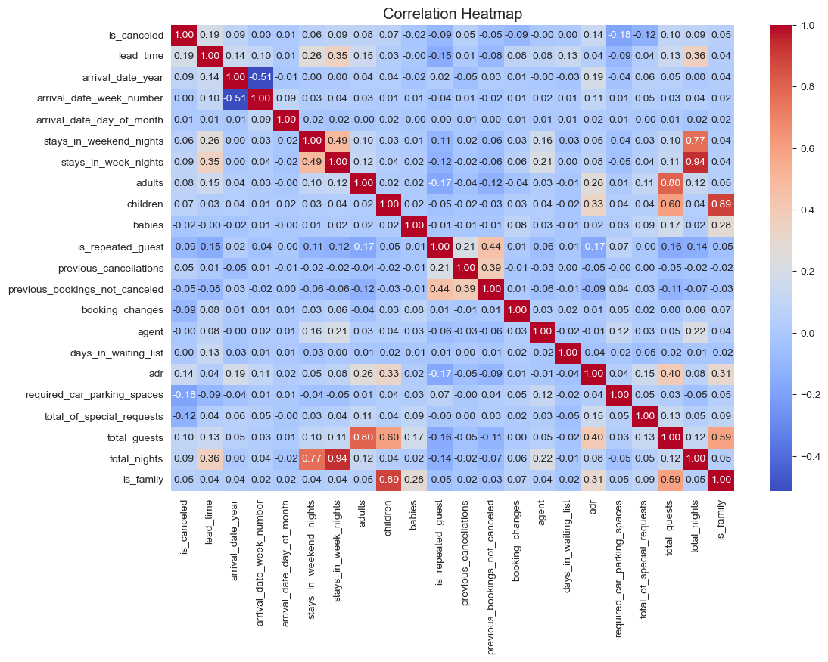
Figure 13. Heatmap of pairwise correlations between all numeric variables.
Technique: A seaborn heatmap with annotated coefficients and a diverging coolwarm colormap — the only practical way to communicate many pairwise relationships at once, since a grid of individual scatter plots for 15+ numeric variables would be unreadable. The diverging palette (blue-to-red) makes positive vs. negative correlation instantly distinguishable by hue, not just number.
Insight: Against the cancellation target specifically, lead_time (+0.19) and adr (+0.14) show the strongest positive correlations with is_canceled, while required_car_parking_spaces (−0.18) and total_of_special_requests (−0.12) are the strongest negative correlations — guests who request parking or add special requests are less likely to cancel.
Relevance: These correlations foreshadow the feature-importance ranking in Figure 14: variables that correlate most strongly with cancellation individually are largely the same ones the Random Forest later ranks as most predictive, giving confidence that the model is learning genuine signal rather than noise.

4.2 Predictive Model: Random Forest Classifier
A Random Forest classifier (200 trees, max depth 10) was trained on 11 numeric features to predict is_canceled, using an 80/20 stratified train-test split to preserve the 72.5%/27.5% class balance in both sets.

4.3 Feature Importance
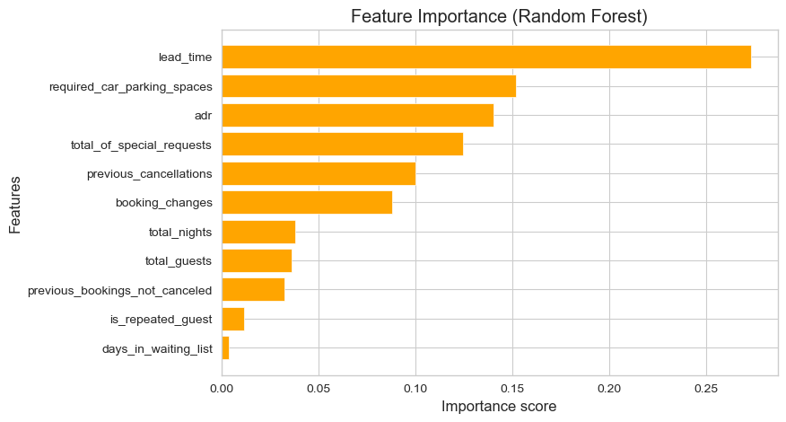
Figure 14. Horizontal bar chart of Random Forest feature importances, ranked descending.
Technique: A horizontal bar chart with the y-axis inverted so the most important feature appears at the top — the natural layout for ranked categorical data with longer text labels, since horizontal bars keep feature names fully readable without rotation or truncation.
Insight: lead_time is the dominant predictor (importance ≈ 0.27), followed by required_car_parking_spaces (≈ 0.15), adr (≈ 0.14), total_of_special_requests (≈ 0.12), and previous_cancellations (≈ 0.10); the remaining features contribute comparatively little.
Relevance: This directly operationalizes the earlier descriptive findings: hotels can build a lightweight early-warning rule from just a few high-signal fields — how far ahead a booking was made, whether parking was requested, the rate paid, and any special requests — rather than needing every field in the dataset.

4.4 Model Performance: ROC Curve
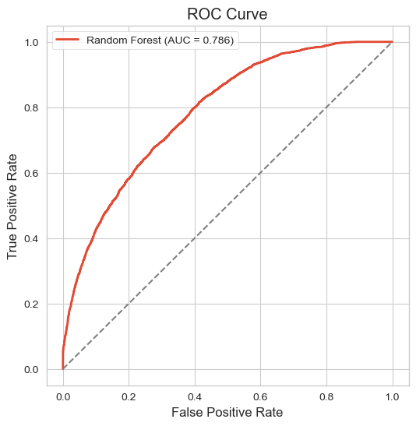
Figure 15. ROC curve for the Random Forest classifier on the held-out test set.
Technique: An ROC curve plotting true positive rate against false positive rate across all classification thresholds, paired with a diagonal reference line — the standard technique for communicating a binary classifier's discriminative power independent of any single decision threshold.
Insight: The model achieves an AUC of 0.786, well above the 0.5 random-guess baseline (the diagonal line), indicating the classifier separates cancelled from non-cancelled bookings with solid, though not perfect, discriminative power.
Relevance: An AUC of ~0.79 is strong enough to rank bookings by cancellation risk for practical use — e.g., prioritizing high-risk reservations for confirmation calls or flexible-rate offers — while leaving room for improvement through additional features such as booking channel or seasonality.

5. Key Statistics Summary
Metric | Value
Total bookings | 87,203
City Hotel share | 61.1% (53,272 bookings)
Resort Hotel share | 38.9% (33,931 bookings)
Cancellation rate | 27.5% (24,008 of 87,203)
Median ADR | $98.25 (mean $105.53)
Median ADR — City vs Resort | $105.30 vs $79.66
Median lead time | 49 days (mean 78.5)
Median stay length | 3 nights (mean 3.58)
Top source market | Portugal — 27,779 bookings (31.9%)
Top predictor of cancellation | lead_time (importance 0.27)
Cancellation model AUC | 0.786

6. Conclusion
Across fifteen visualizations, a consistent story emerges: City Hotel is the larger, higher-priced, higher-volume property, sourced predominantly from Portugal and Western Europe through Online Travel Agents, serving mostly transient individual travelers on short, BB-inclusive stays. Roughly a quarter of all bookings never convert into a stay, and that risk is not random — it concentrates in bookings made far in advance, at higher rates, without parking requests or special requests attached.
The visualization choices throughout were matched deliberately to the analytical question at hand: bar and pie charts for composition, histograms for distribution shape, box plots and scatter plots for group and pairwise comparisons, a heatmap for multivariate correlation, and a feature-importance chart plus ROC curve to communicate a predictive model's logic and reliability. Together, these charts move from describing what happened in the data to explaining why it happened and building a tool — the Random Forest classifier — that can act on it going forward.
Suggested next steps: incorporate booking channel and seasonal/monthly effects into the cancellation model to push AUC higher, and consider a targeted retention workflow (e.g., confirmation outreach or flexible cancellation policies) for bookings the model flags as high-risk lead-time cases.

